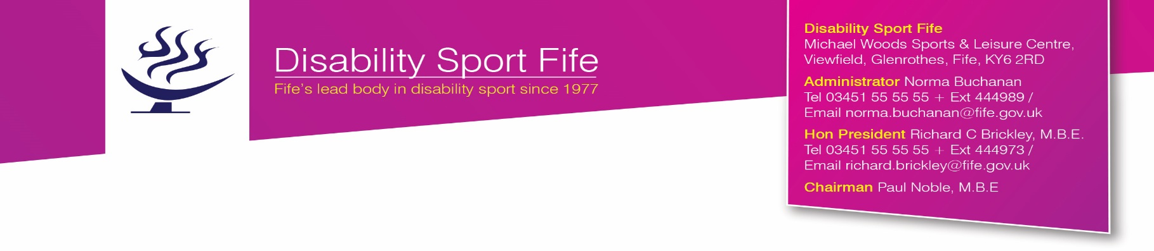
DSF/AberhillBowls/RCB/NB
2 August 2017

M E M O R A N D U M

To: Central Fife CSS, West Fife CSS, East Fife CSS
Darryl Stewart, Matthew Blissett, Briony Clark, Steven Anderson,
Robert Anderson, Adam Faulds, Sandy Allan, Pamela Mitchell

cc. Alex McLean
Math Thomson
Sandy McKenzie
David Watson
John Collins
Mike Mowat

From: Administrator, Disability Sport Fife

INDOOR TOURNAMENT FOR BOWLERS WITH A LEARNING DISABILITY
Supported by the East Fife Indoor Bowling Club

VENUE: EAST FIFE INDOOR BOWLING CLUB, ABERHILL, LEVEN

DATE: THURSDAY 7 SEPTEMBER 2017

TIME: 10.30 AM START

OFFICIALS: Members of local bowling clubs – co-ordinators MathThomson and Alex McLean.

ENTRY FEE: £2 per bowler. Cheques in favour of DSF.

ENTRIES: Closing date for entries Friday 25 August 2017

PLEASE NOTE ANY NUMBER OF ENTRIES WELCOME.

There is no restriction on entries. Enter as many players as you wish.

CATERING: Packed Lunches will be required. Tea will be provided and the bar will be available for refreshments.

DRESS: BOWLING SHOES SHOULD BE WORN. IF NOT SOFT SHOES WITHOUT HEELS MUST BE WORN (this condition must be strictly adhered to). Staff are requested to ensure that their bowlers are appropriately dressed for a bowling tournament. No football tops please. White top the preferred option.

CONDUCT: Staff are asked to ensure that players are kept up to date with play to assist the smooth running of the tournament. Only players who have received appropriate tuition and time to practice should be entered.

All players will compete in Divisions based on their ability.

DIVISIONS A → D (FULL RINK) (Open, graded, mixed and/or single sex)

There will be separate single hand competitions for both male and female bowlers. Four bowls, the usual outdoor size, will be used. Five ends will be played. The final will be played over seven ends. There will be no trial end after the first game. The jack will be placed by the Marker as thrown. The rink will be used in both directions. Each member organisation can enter as many players as they wish. Players may only be entered for this competition if they have practiced on an indoor rink.

CARPET BOWLS COMPETITION
There will be no carpet bowls competition this year. The Fife Carpet Bowls Championships will be held at the Michael Woods Sports Centre, Glenrothes on Wednesday 22 November and it is felt that this event incorporates players of all abilities.

Entries to be returned to the Administrator, Disability Sport Fife, Michael Woods Sports & Leisure Centre, Viewfield, Glenrothes, Fife KY6 2RD no later than Friday 25 August 2017 - norma.buchanan@fife.gov.uk
FIFE INDOOR TOURNAMENT FOR BOWLERS WITH A LEARNING DISABILITY

East Fife Indoor Bowling Club, Aberhill
Thursday 7 September 2017 – 10.30 start

ENTRIES ON BEHALF OF
(Individual/Member Organisation)

DIVISIONS A → D
MALE |  | FEMALE
1. |  | 1.
2. |  | 2.
3. |  | 3.
4. |  | 4.
5. |  | 5.
6. |  | 6.
7. |  | 7.
8. |  | 8.
9. |  | 9.
10. |  | 10.
11. |  | 11.
12. |  | 12.

Entries to be returned to the Administrator, Disability Sport Fife, Michael Woods Sports & Leisure Centre, Viewfield, Glenrothes, Fife KY6 2RD no later than Friday 25 August 2017 – norma.buchanan@fife.gov.uk

DSF/AberhillBowls17/RCB/NB

INDOOR TOURNAMENT
FOR BOWLERS WITH A LEARNING DISABILITY

East Fife Indoor Bowling Club, Aberhill
Thursday 7 September 2017 – 10.30 start

(Closing date for entries – Friday 25 August 2017)

INVOICE

NUMBER OF COMPETITORS |  | @ £2 PER ATHLETE = £

Cheques made payable to Disability Sport Fife

Group/Individual:
Contact Person:
Address:
Tel No.:
Email:
Signature:

Please return this Invoice and appropriate entry fees with entry form to: Norma Buchanan, Administrator, Disability Sport Fife, Michael Woods Sports & Leisure Centre, Viewfield, Glenrothes, Fife KY6 2RD (Tel. 03451 55 55 55 Ext 444989 or email norma.buchanan@fife.gov.uk

DSF/AberhillBowls17/RCB/NB

