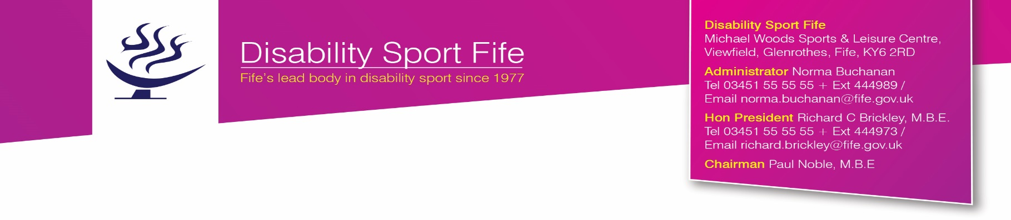

DISABILITY SPORT FIFE AWARDS 2017

Nominations are invited from Member Organisations or individuals associated with Disability Sport Fife for any of the following awards:

ATHLETE LONG SERVICE AWARDS

1/2 ACCESS AWARDS (2)

Awarded to any sports person(s) with a disability who has demonstrated exceptional qualities of sportsmanship, determination, commitment, leadership, achievement that single him/her out from others during their career to date. The Access Awards are presented to athletes and players of any level of ability.

ATHLETE PERFORMANCE AWARDS

3 SWIMMER OF THE YEAR –The Leslie Inglis Trophy

To be presented to the swimmer who has been particularly successful during the past year. The individual to be recognised will have achieved excellence in performance swimming at the highest level.

4 ATHLETE OF THE YEAR – Colin Keay Award

To be presented to the athlete who has achieved exceptional levels of success during the past year. The athlete to be recognised will have achieved a high level of success in performance athletics.

5 BOWLER OF THE YEAR – Alex McLean Award

To be presented to the outstanding Fife bowler of the past year. Any bowler nominated will have achieved a high level of performance in indoor, outdoor, carpet or ten pin bowling in the past year.

6 MOST IMPROVED SWIMMER OF THE YEAR – Paul Noble MBE Award

To be presented to the swimmer who has made the most significant improvement in the past year at any level of competitive swimming.

7 FOOTBALLER OF THE YEAR – Penman Family Award

To be presented to the outstanding junior or senior footballer of the past year.

8 WHEELCHAIR ATHLETE OF THE YEAR – The Ian McNab Memorial Trophy

To be presented to a wheelchair athlete who in the year past has achieved a high level of performance in any sport. The trophy was donated by the McNab family in memory of Ian who was a most influential and respected member of Disability Sport Fife during the early years. Ian was an exceptional all round athlete who was ahead of his time in disability sport.

9 BADMINTON PLAYER OF THE YEAR – John Hick Cup

Trophy donated by Kerry Hick wife of the late John Hick who was a wonderful ambassador for DSF. The Cup will be presented to the outstanding badminton player of the year past.

SPECIAL RECOGNITION AWARDS

10 LIFETIME ACHIEVEMENT AWARD – Gary Innes Award

To be presented to an individual athlete or player who has been involved in disability sport for a significant period of time.

11 JUNIOR SPORTS PERSON OF THE YEAR – Aileen Harper Award

This award recognises the leading young sports person under 18 who has excelled in any sport during the year past.

12 JUNIOR ENDEAVOUR AWARD – Caroline Baird Award

To be presented to a junior athlete who has demonstrated a particularly high level of commitment in any sport at any level.

13 SENIOR ENDEAVOUR AWARD – Tom Donaldson Award

To be presented to a severely disabled sports person who has achieved a high level of success in disability sport.

14 SPECIAL ACHIEVEMENTS AWARDS – in memory of the late Ian Cowper

These awards recognise athletes and players with additional support needs who have produced outstanding performances during the year past. At any Annual Awards Evening up to three Fife athletes/players may be recognised.

COACH AND VOLUNTEER AWARDS

15 COACH OF THE YEAR – Eddie Campbell Award

This award recognises a coach who has supported a DSF athlete or team to achieve success in performance sport.

16 EMERGING COACH OF THE YEAR – Ann Swann Award

To be presented to a coach who is new to disability sport in Fife.

17 SPECIAL RECOGNITION AWARDS – Adam Morley Awards

To be presented to representatives from partner or member organisations who have made a significant contribution to DSF over the years.

18 VOLUNTEER SPECIAL RECOGNITION – Anne Hay Award

To be presented to an individual who has demonstrated exceptional commitment to DSF as a volunteer. The award is presented in the name of the late Anne Hay who devoted many years of services to DSF.

PREMIER AWARDS

19 SERVICE TO SPORT – Steve Donnelly Award

To be presented to an individual who has contributed as a coach, volunteer or administrator to disability sport in Fife. Disability Sport Fife is strong because of its team of volunteers. The service to sport award recognises the importance of volunteers to the Fife programme.

20 AMBASSADOR OF THE YEAR – Alec Thorburn Award

This award is presented in memory of one of DSF’s most committed volunteers. The award recognises an individual from any organisation who has supported and promoted DSF across a range of areas.

21 MEMBER ORGANISATION OF THE YEAR – David Thomson Award

This new award is presented in the name of the late David Thomson, a founder member of DSF. The award will be presented to a DSF member organisation that stands out among others because of its commitment to the ethos, aims and objectives of DSF.

All member organisations and individuals connected with Disability Sport Fife may nominate, in writing or by email direct to Norma Buchanan, Disability Sport Fife Administrator, Michael Woods Sports Centre, Viewfield, Glenrothes KY6 2RD or email (norma.buchanan@fife.gov.uk) including the following information:

a) Name, address and telephone number of individual being nominated plus the same for the individual submitting the nomination.

b) A short statement on why this person should be considered for any of the awards.

Only nominations submitted before Friday 28 April 2017 will be considered. The presentations will be made at the DSF Awards Evening on Monday 8 May 2017 at 19.00 hrs in the Michael Woods Sports and Leisure Centre, Glenrothes.

DISABILITY SPORT FIFE AWARDS 2017

Award Name:
Name of Nominee:
(Address)
(Tel No.)
(Email)
Name of Proposer:
(Address)
(Tel No.)
(Email)

Description of Nominee’s qualities and strengths

(Please use another sheet if necessary)

Please return before Friday 28 April 2017 to Norma Buchanan, Administrator, Disability Sport Fife, Michael Woods Sports Centre, Viewfield, Glenrothes KY6 2RD or email norma.buchanan@fife.gov.uk

