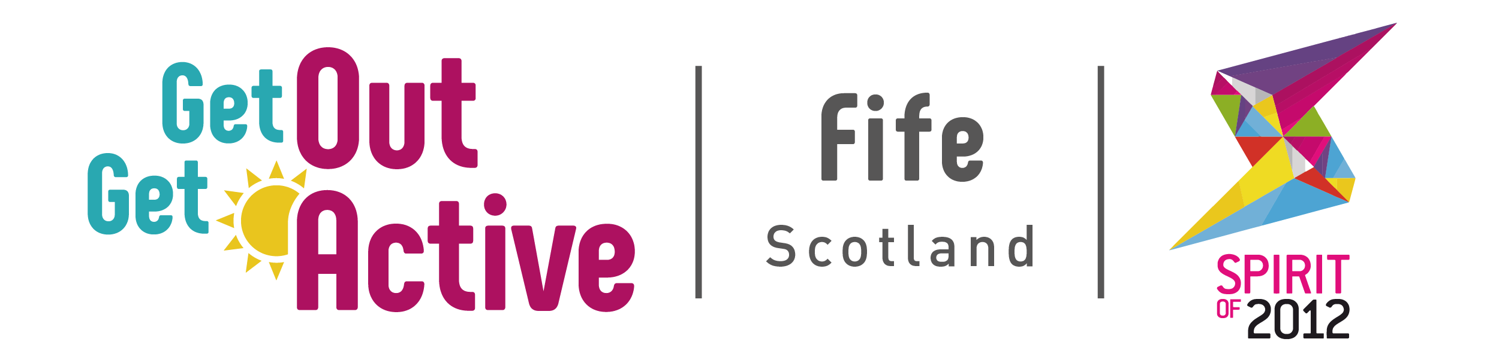
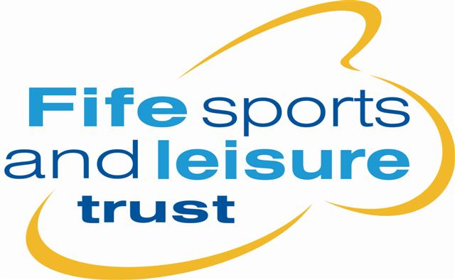
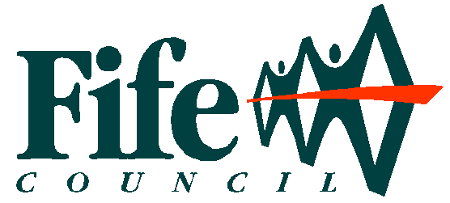
COACH EDUCATION CALENDAR 2018
(Updated Dec 2017)

Course | DAY | DATE | TIME | Venue | Tutor(s)
How to Coach Disabled People in Sport – Sports Coach UK Workshop | Tues | 6 Feb  2018 | 18.00-21.00 | University of St Andrew (closed course) | Richard Brickley
Disability Inclusion Training | Tues | 13 Feb & 20 Feb  2018 | 16.00-19.00 | Auchmuty High School, Glenrothes | Heather Lowden, Richard Brickley &  Pamela Robson
Pool Workshop (GOGA) | Wed | 14 Feb  2018 | 09.30-13.30 | Lochgelly High School | Richard Brickley
How to Coach Disabled People in Sport – Sports Coach UK | Mon | 26 Feb  2018 | 18.00-21.00 | Michael Woods Sports & Leisure Centre, Glenrothes | Richard Brickley
Boccia Leaders Workshop | Wed | 28 Feb  2018 | 12.00-15.00 | Michael Woods Sports & Leisure Centre, Glenrothes | Claire Morrison
Walk Leaders Course (GOGA) | Wed | 23 May  2018 | 11.30-16.30 | Michael Woods Sports & Leisure Centre, Glenrothes | Vivienne McNiven
How to Coach Disabled People in Sport – Sports Coach UK | Mon | 24 Sept  2018 | 18.00-21.00 | Michael Woods Sports & Leisure Centre, Glenrothes | Richard Brickley
Walk Leaders Course (GOGA) | Tues | 2 Oct  2018 | 11.30-16.30 | Michael Woods Sports & Leisure Centre, Glenrothes | Vivienne McNiven

